GAMA BAJA

INTEL

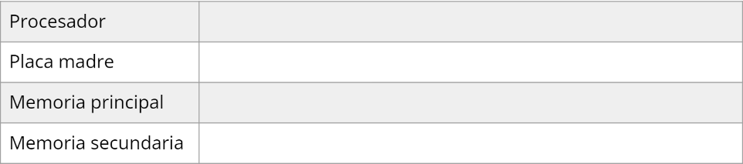

Mother Asrock B360M

Core i3 7100

Memoria Kingston DDR4 4GB 2666Mhz

[Disco Rígido Seagate 1TB Barracuda 64MB SATA 6GB/s](https://compragamer.com/armatupc/?listado_prod=&seccion=5&nro_max=50&tipo=49&mother=12972&cpu=9363&ccpu=2094&mem=13056&mem_full=1&video=&video_full=1&hd=3749)

AMD



Disco Rígido Seagate 1TB Barracuda 64MB

Memoria Kingston DDR4 4GB 2666Mhz

Motherboard B450

Ryzen 3 2200g

A ELECCION



Disco Rígido Seagate 1TB Barracuda 64MB

Memoria Kingston DDR4 4GB 2666Mhz

Mother Asrock B360M

[Core i3 9100 4.2GHz](https://compragamer.com/armatupc/?listado_prod=&seccion=5&nro_max=50&tipo=49&mother=12972&cpu=9363)

GAMA MEDIA

INTEL

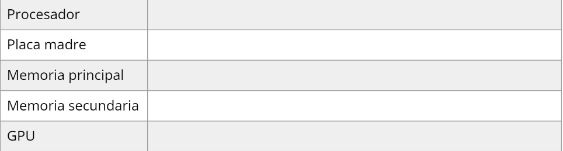

Memoria Kingston DDR4 4GB 2666Mhz Fury x2 xxBeast **Cl16**

[Disco Solido SSD Team 1TB GX2 530MB/s](https://compragamer.com/armatupc/?listado_prod=&seccion=5&nro_max=50&tipo=49&mother=13058&cpu=8633&ccpu=2094&mem=13056&mem_full=1&video=&video_full=1&hd=10112)

GeForce GT 1030 2GD4 LP OC

Mother Asrock B365M-OEM

Core i5 9400 4.1GHz Turbo 1151 9th Gen

AMD



Memoria Kingston DDR4 4GB 2666Mhz Fury x2

[GeForce GTX 1650 4GB GDDR6](https://compragamer.com/armatupc/?listado_prod=&seccion=5&nro_max=50&tipo=26&mother=6165&cpu=8780&ccpu=2094&mem=&mem_full=1&video=13057)

[Disco Solido SSD Team 1TB GX2 530MB/s](https://compragamer.com/armatupc/?listado_prod=&seccion=5&nro_max=50&tipo=49&mother=13058&cpu=8633&ccpu=2094&mem=13056&mem_full=1&video=&video_full=1&hd=10112)

A320M Asrock

[AMD RYZEN 5 3600 4.2GHz](https://compragamer.com/armatupc/?listado_prod=&seccion=5&nro_max=50&tipo=26&mother=6165&cpu=8780)

A ELECCION



Memoria Kingston DDR4 4GB 2666Mhz Fury x2

[GeForce GTX 1050 ti](https://compragamer.com/armatupc/?listado_prod=&seccion=5&nro_max=50&tipo=26&mother=6165&cpu=8780&ccpu=2094&mem=&mem_full=1&video=13057)

[Disco Solido SSD Team 1TB GX2 530MB/s](https://compragamer.com/armatupc/?listado_prod=&seccion=5&nro_max=50&tipo=49&mother=13058&cpu=8633&ccpu=2094&mem=13056&mem_full=1&video=&video_full=1&hd=10112)

A320M Asrock

[AMD Ryzen 5 1600 AF Zen](https://compragamer.com/armatupc/?listado_prod=&seccion=5&nro_max=50&tipo=26&mother=6165&cpu=9916)

GAMA ALTA

INTEL



[GeForce RTX 2060 6GB GDDR6](https://compragamer.com/armatupc/?listado_prod=&seccion=5&nro_max=50&tipo=26&mother=6979&cpu=10460&ccpu=12952&mem=&mem_full=1&video=12813)

Disco Solido SSD M.2 Team 2TB Cardea C440 5000MB/s

[Memoria Team DDR4 8GB 2666MHz T-Force Delta](https://compragamer.com/armatupc/?listado_prod=&seccion=5&nro_max=50&tipo=26&mother=6979&cpu=10460&ccpu=12952&mem=12492) x2

Mother Gigabyte H410M S2H V3

Core i7-10700

AMD



[GeForce RTX 2060 6GB GDDR6](https://compragamer.com/armatupc/?listado_prod=&seccion=5&nro_max=50&tipo=26&mother=6979&cpu=10460&ccpu=12952&mem=&mem_full=1&video=12813)

[Disco Solido SSD M.2 Team 2TB Cardea C440 5000MB/s NVMe PCIe Gen4](https://compragamer.com/armatupc/?listado_prod=&seccion=5&nro_max=50&tipo=26&mother=6979&cpu=10460&ccpu=12952&mem=&mem_full=1&video=&video_full=1&hd=12608)

[Memoria Team DDR4 8GB 2666MHz T-Force Delta](https://compragamer.com/armatupc/?listado_prod=&seccion=5&nro_max=50&tipo=26&mother=6979&cpu=10460&ccpu=12952&mem=12492) x2

Mother Gigabyte AB350M V2.0 DS3H AM4

Amd Ryzen 7 3800xt

A ELECCION



Mother ASUS PRIME B560M-A S1200 11th Gen PCIe 4.0

[Core i7 11700F S1200 11th Gen](https://compragamer.com/armatupc/?listado_prod=&seccion=5&nro_max=50&tipo=49&mother=12422&cpu=11907)

[GeForce RTX 2060 6GB GDDR6](https://compragamer.com/armatupc/?listado_prod=&seccion=5&nro_max=50&tipo=26&mother=6979&cpu=10460&ccpu=12952&mem=&mem_full=1&video=12813)

Disco Solido SSD M.2 Team 2TB Cardea C440 5000MB/s

[Memoria Team DDR4 8GB 2666MHz T-Force Delta](https://compragamer.com/armatupc/?listado_prod=&seccion=5&nro_max=50&tipo=26&mother=6979&cpu=10460&ccpu=12952&mem=12492) x2